I have confirmed that I observed the output "hello world" using the source code

**-- hello.cpp (in C++)**

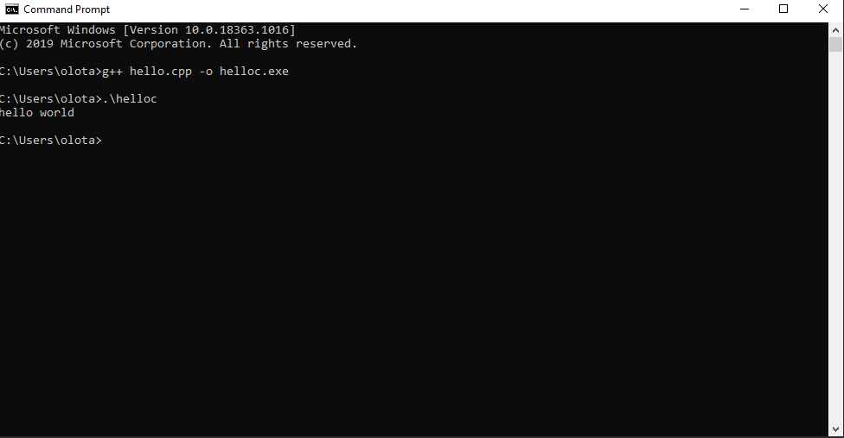

**-- hello.m (in Matlab)**

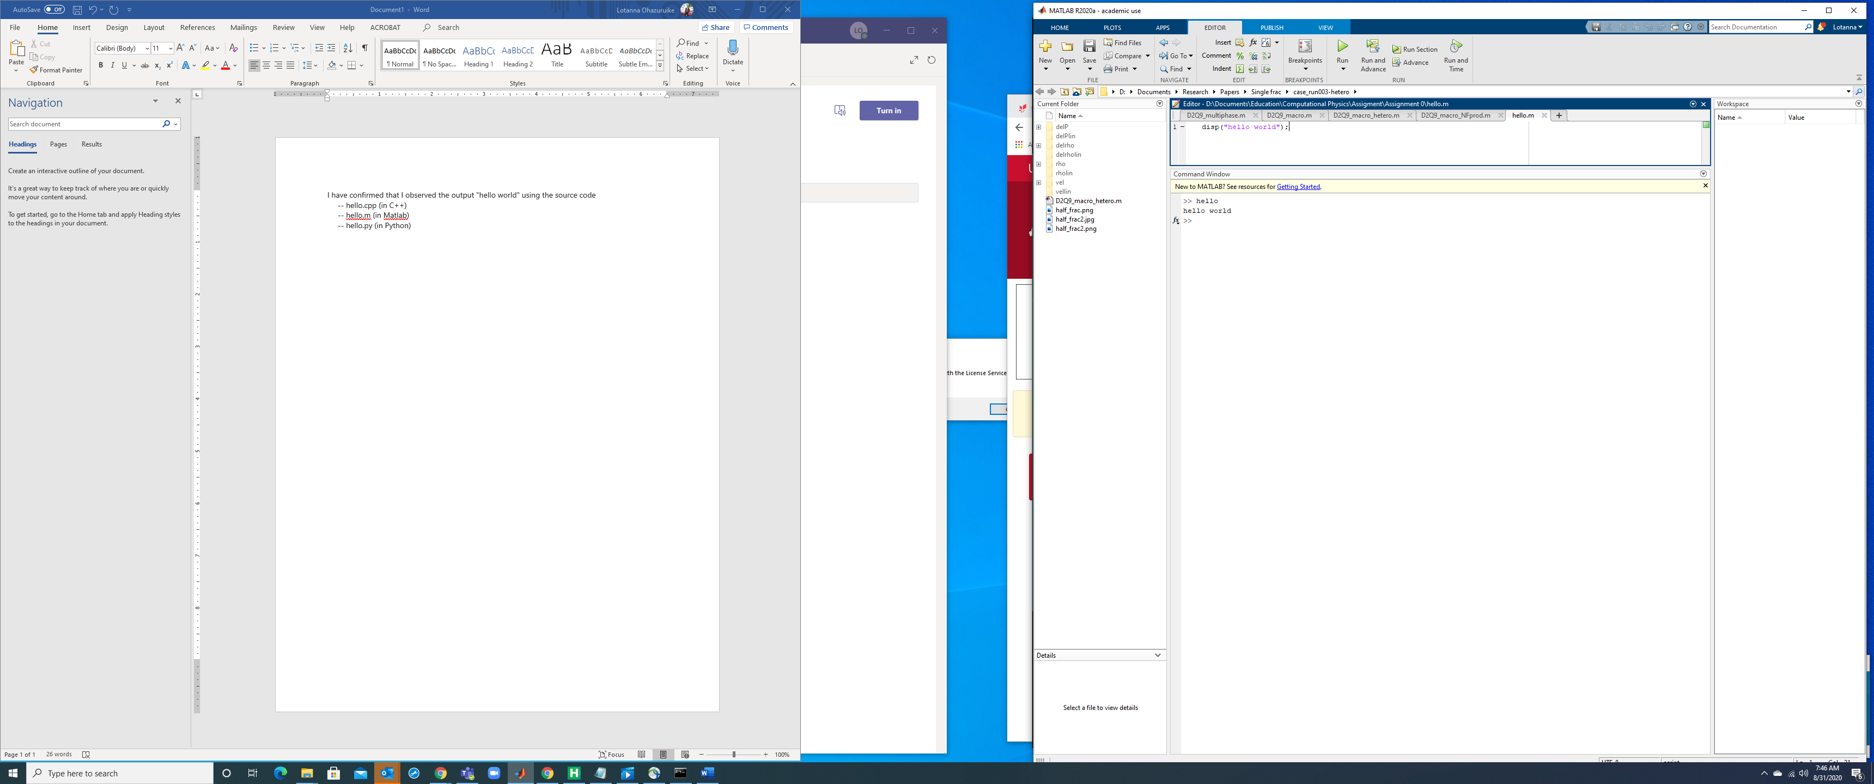

**-- hello.py (in Python)**

